1. Design the following web page using HTML 5 and CSS 3.
2. 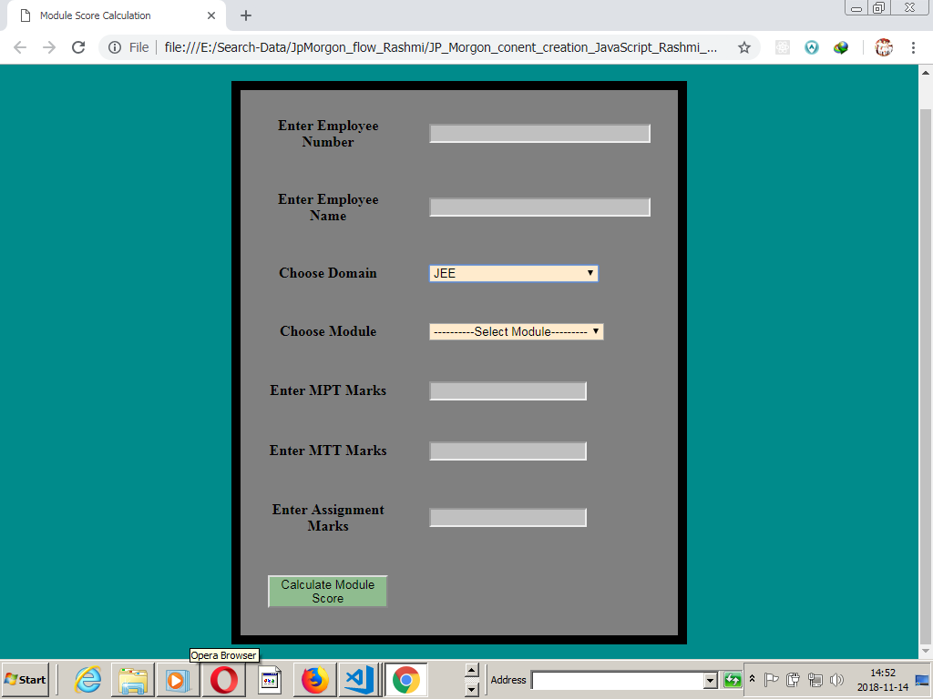

1. All fields are mandatory

2. Employee Number of the trainee should be a 6 digit number

3. Name of the trainee should accept maximum 30 letters

4. Valid values for Domain should be

i. JEE

ii. .NET

5. The values in the module name drop down are dependent on domain name

Valid module names for JEE Domain

i. Core Java

ii. Servlet-JSP

iii. Spring

Valid module names for .NET Domain

iv. C #

v. ADO.NET

vi. ASP.NET

6. MPT, MTT and Assignment marks should be a non negative number.

7. Write appropriate javascript function which calculates and displays the score in an alert box once the data is submitted.